**Overview**

Box Capture is an IOS-specific mobile application that allows you to take/record pictures and other media using your device’s camera and upload them instantly to your Box account. This process is seamless and removes the need to perform a separate upload process after taking a picture or video. The Box Capture app can also record when and where the picture was taken, as well as allow inputting of comments for future reference.

By simplifying the process of uploading your pictures to Box, Box Capture makes sharing pictures, audio, video and scanned documents quick and easy. Anything that can be captured with your camera can be instantly saved and shared with anyone using your Box account.

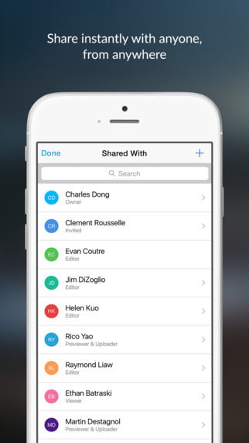

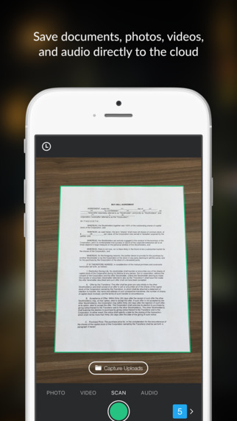

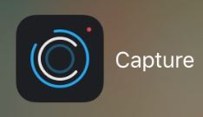

The Box Capture app uses your device's camera to select and record your media of choice, which can then be shared with anyone using your Box account

**Set-Up and Configuration**

Box Capture can be downloaded from the iTunes Apple store for mobile apps. When the download finishes, click on **Install**.

1. Search for Box Capture in the App Store and install.
2. Open Box Capture and select Box as the destination.
3. Log into your Box account.
4. Give the Box Capture app permission to use your device’s camera. If you choose to have the geo-location tagged on your files, then GPS will need to be permitted via your Settings app.
5. Select the folder you want to save to. The default is set as “Capture Uploads" (see below).

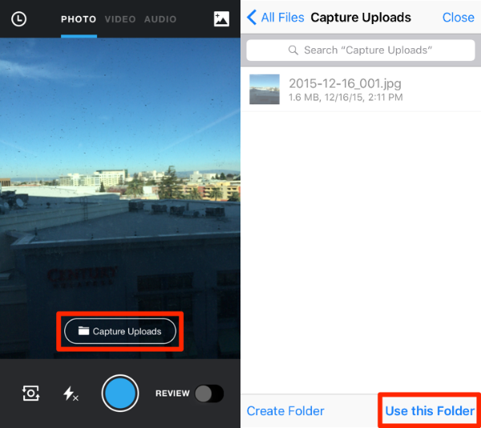

The default location of your files will be "Capture Uploads." You can set up different folders to organize files by client, location, event, etc.

**FAQs**

* **Which platforms is Box Capture available on?**

Box Capture is currently available only for IOS devices such as an iPhone or iPad. There is no Android version supported yet.

* **Do I need to make a Box account?**

Yes, you will need a Box account to store Box Capture files to your Box account, and share them with others.

* **How do I share a file with someone?**

Access your files by clicking the **Recents** tab (the clock-like icon, circled in red below).



From there, you can view your files and conduct actions such as saving, renaming, moving and sharing by clicking on the "ellipses" in the top right corner. To share the file, select “Folder Access” which will let you share the file with others in your Box account.

* **What are some common uses for Box Capture?**

You can use Box Capture for multiple purposes, such as scanning receipts to an "Expenses" folder, recording interviews, and capturing pictures with geo-locational information.